Name: ________________________ Date: __________
Anglo-Saxon Webquest
The purpose of this webquest is to explore the daily life, religion, and culture of the Anglo-Saxons. Learning about these aspects of Anglo-Saxon life will enhance your understanding of the time period and the Anglo-Saxon literature we will study.

Review Questions:

Who lived in England prior to the Anglo-Saxons?
Who invaded next?
Where did the Anglo-Saxons come from?
__________________________________________________________________________________________
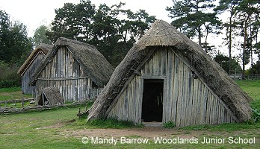
Homes and Halls

Go to the following website:
http://primaryhomeworkhelp.co.uk/saxons/houses.htm

- What happened to many of the towns set up by the Romans?

- What materials were homes constructed from?

- Describe how the houses were set up.

- Who lived in the Hall (mead hall)?

- Describe the set-up and atmosphere of a mead hall.

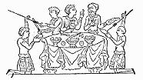

Food and Drink

Go to: http://primaryhomeworkhelp.co.uk/saxons/food.htm

- What types of food did Anglo-Saxons grow?

- What did they drink instead of water? Why?

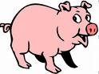
- Why were many Anglo-Saxons vegetarians?

- What was the only type of animal used just for its meat?

Go to: http://www.marga.org/food/int/anglosaxon/

- Scroll to the bottom and click on the three recipes. Of these three, which would you most prefer to eat? Why?

- What are three ingredients in the recipe above?
A.
B.
C.

Social Structure

Go to: http://www.suite101.com/external_link.cfm?elink=http://www.britainexpress.com/History/anglo-saxon_life.htm

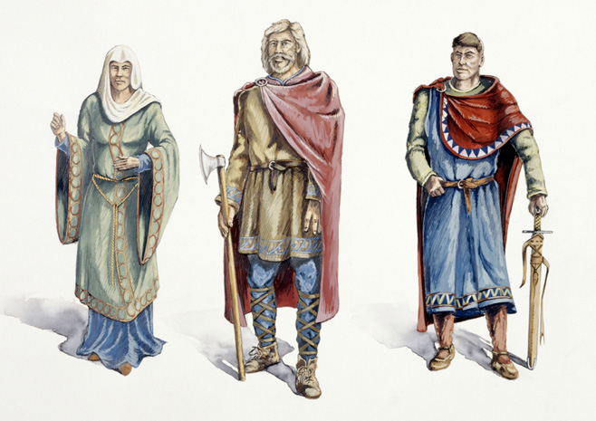
Scroll down to “A Lord’s Life.”

- Who was at the top of the social ladder?

- What was this person expected to provide?

- What were the two social classes below the king?

- What are three ways people became slaves?
A.
B.
C.

Go to http://www.octavia.net/anglosaxon/slaves.htm

- What was the penalty for killing a slave?

- What was the penalty for raping a slave?

- What was the penalty for one slave raping another?

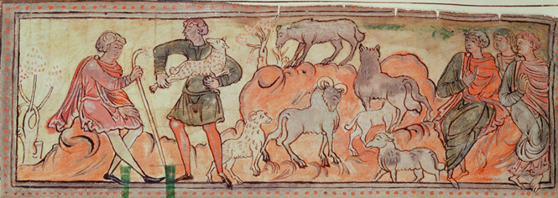
Daily Life

Go to: http://www.wikitree.com/articles/year-1000/

- If you were to go back in time to the year 1000 and meet an Anglo-Saxon, what is the first thing you would notice?

- What happened to people after the year 1000 and before today that made them smaller?

- At what age was a boy considered old enough to swear an oath to the king?

- When did most girls marry?

- When did most adults die?

- What disease found in skeletal remains that tells us these people worked hard?

Go to http://www.hullwebs.co.uk/content/c-anglo-saxon/home-life/anglo-saxon-women.htm

- What was morgengifu, and when was it given?

- If a woman wished to divorce her husband, how much money and property was she entitled to?

Medicine

Go to http://www.octavia.net/wort/wortcunningequalsherbalsmarts.htm
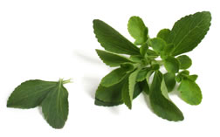
- What is the title of this page?

- What does it mean?

- What items were used in healing both the body and spirit?

- What did people do to wounds to speed healing?

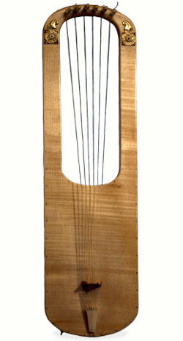
- What is the title of one of the Charms listed?

Games and Entertainment

Go to http://www.bbc.co.uk/schools/primaryhistory/anglo_saxons/stories_and_pastimes/

- What story is mentioned under “story-telling?”

- Click on “Games and Sports.” What are some sports they enjoyed?

- What were the gambling dice found in the grave made from?

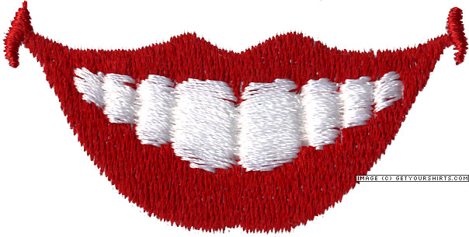
Lookin’ Good

Go to: http://www.octavia.net/9thclife/Cosmetics.htm

- What are two things Anglo-Saxons used to brush and polish their teeth?

- What did the Swedish anthropologist find in the teeth of 24 Viking-era men?

- What were some possible purposes for this?

- Look at the paragraph that starts with “Long Hair.” Click on the link that says “costly fine.” What were the punishments for the following?
  - Shaving a man’s head (without tying him up)= ________ shillings
  - Shaving a man’s beard= __________ shillings
  - Tying a man up and shaving his head= ________ shillings

- The next paragraph gives the fine for cutting off an arm or leg. What is it?
_________ shillings

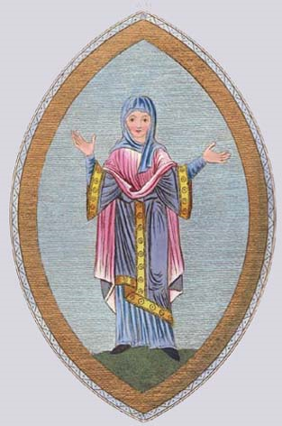
- How does this penalty tell us about long hair on men?

Scroll to the top of the page. (http://www.octavia.net/9thclife/Clothing.htm)

- What material was used for most clothing?

- Did women wear underwear other than a slip (shift)?

- What did they wear over their shift?

- What were some colors of clothing?

- What did men wear?

Go back to http://www.octavia.net/9thclife/Cosmetics.htm

Scroll to the bottom of the page.

- What did people use for eye makeup?

- What are 3 reasons people throughout the ages have had tattoos?
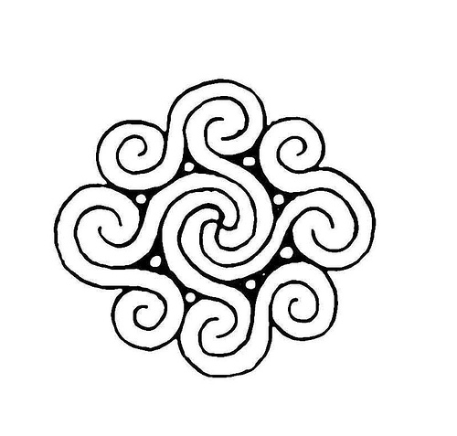

- How were tattoos accomplished?

Religion

Go to http://www.hullwebs.co.uk/content/c-anglo-saxon/religion/religion.htm

- What are some aspects of life that the Anglo-Saxon pagan (heathen) gods ruled?
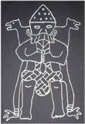

- Go to http://gwydir.demon.co.uk/jo/roman/daysweek.htm

We get the names of the days of the week from Saxon gods. Fill in the blanks below:

Monday= _____________’ s day (god of _____________________________)
Tuesday= _____________’ s day (god of _____________________________)
Wednesday=_____________’ s day (god of _____________________________)
Thursday=_____________’ s day (god of _____________________________)
Friday=_____________’ s day (goddess of _____________________________)
Sunday=_____________’ s day (god of _____________________________)

